Chapter 10
100
Externalities

EXTERNALITIES

WHAT’S NEW IN THE SEVENTH EDITION:

There is a new In the News feature on “What Should We Do about Climate Change.”

LEARNING OBJECTIVES:

By the end of this chapter, students should understand:

➢ what an externality is.

➢ why externalities can make market outcomes inefficient.

➢ the various government policies aimed at solving the problem of externalities.

➢ how people can sometimes solve the problem of externalities on their own.

➢ why private solutions to externalities sometimes do not work.

CONTEXT AND PURPOSE:

Chapter 10 is the first chapter in the microeconomic section of the text. It is the first chapter in a three-chapter sequence on the economics of the public sector. Chapter 10 addresses externalities—the uncompensated impact of one person’s actions on the well-being of a bystander. Chapter 11 will address public goods and common resources (goods that will be defined in Chapter 11) and Chapter 12 will address the tax system.
In Chapter 10, different sources of externalities and a variety of potential cures for externalities are addressed. Markets maximize total surplus to buyers and sellers in a market. However, if a market generates an externality (a cost or benefit to someone external to the market) the market equilibrium may not maximize the total benefit to society. Thus, in Chapter 10 we will see that while markets are usually a good way to organize economic activity, governments can sometimes improve market outcomes.

KEY POINTS:

• When a transaction between a buyer and seller directly affects a third party, the effect is called an externality. If an activity yields negative externalities, such as pollution, the socially optimal quantity in a market is less than the equilibrium quantity. If an activity yields positive externalities, such as technology spillovers, the socially optimal quantity is greater than the equilibrium quantity.

• Governments pursue various policies to remedy the inefficiencies caused by externalities. Sometimes the government prevents socially inefficient activity by regulating behavior. Other times it internalizes an externality using corrective taxes. Another public policy is to issue permits. For example, the government could protect the environment by issuing a limited number of pollution permits. The result of this policy is largely the same as imposing corrective taxes on polluters.

• Those affected by externalities can sometimes solve the problem privately. For instance, when one business imposes an externality on another business, the two businesses can internalize the externality by merging. Alternatively, the interested parties can solve the problem by negotiating a contract. According to the Coase theorem, if people can bargain without cost, then they can always reach an agreement in which resources are allocated efficiently. In many cases, however, reaching a bargain among the many interested parties is difficult, so the Coase theorem does not apply.

CHAPTER OUTLINE:

I. Definition of externality: the uncompensated impact of one person’s actions on the well-being of a bystander.

A. If the impact on the bystander is adverse, we say that there is a negative externality.

B. If the impact on the bystander is beneficial, we say that there is a positive externality.
Give students several examples of both positive and negative externalities. Use current health debates or political topics to maintain interest.


C. In either situation, decisionmakers fail to take account of the external effects of their behavior.

II. Externalities and Market Inefficiency

A. Welfare Economics: A Recap

1. The demand curve for a good reflects the value of that good to consumers, measured by the price that the marginal buyer is willing to pay.

2. The supply curve for a good reflects the cost of producing that good.

3. In a free market, the price of a good brings supply and demand into balance in a way that maximizes total surplus (the difference between the consumers’ valuation of the good and the sellers’ cost of producing it).
Figure 1

B. Negative Externalities

1. Example: An aluminum firm emits pollution during production.
ALTERNATIVE CLASSROOM EXAMPLE:
A coal-fired power plant emits pollution during production.

2. Social cost is equal to the private cost to the firm of producing the aluminum plus the external costs to those bystanders affected by the pollution. Thus, social cost exceeds the private cost paid by producers.

3. The optimal amount of aluminum in the market will occur where total surplus is maximized.

a. Total surplus is equal to the value of aluminum to consumers minus the cost (social cost) of producing it.

b. This will occur where the social-cost curve intersects with demand curve. At this point, producing one more unit would lower total surplus because the value to consumers is less than the cost to produce it.

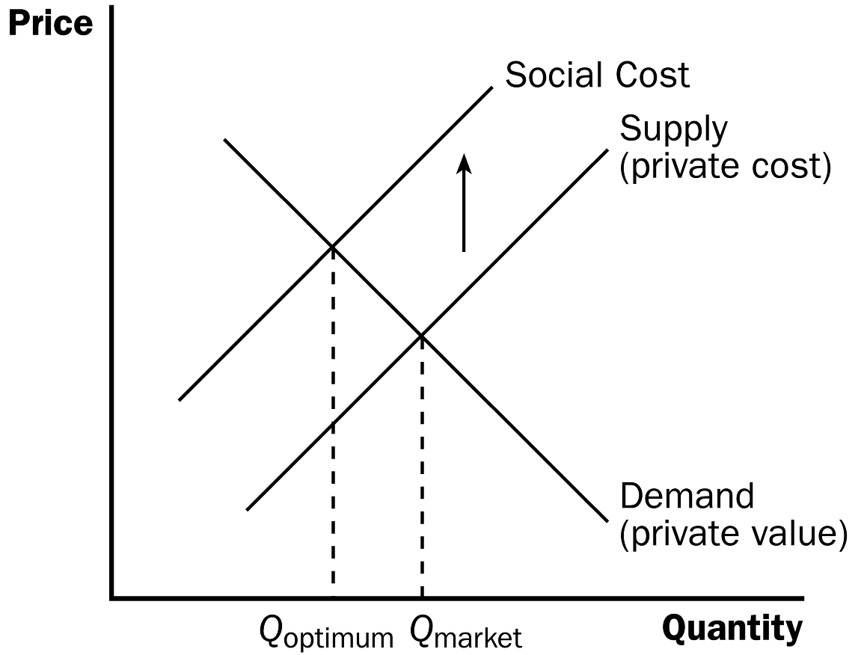
Figure 2

4. Because the supply curve does not reflect the true cost of producing aluminum, the market will produce more aluminum than is optimal.
Make sure that students understand how this pollution by the firm imposes costs on third parties. Point out that the firm is likely emitting pollution because this is the cheapest method of production. Stress that the firm is using a resource in production that it is not paying for.

5. This negative externality could be internalized by a tax on producers for each unit of aluminum sold.

6. Definition of internalizing an externality: altering incentives so that people take account of the external effects of their actions.
This is a good time to discuss why the government taxes goods like alcohol, tobacco, and gasoline. You will find that students have heard the phrase “sin tax,” but they often do not understand why economists might support such taxes (given the deadweight loss from taxes discussed in Chapter 8).

7. In the News: The Externalities of Country Living

a. In The Lorax by Dr. Seuss, urbanization is criticized while country living is considered more environmentally friendly.

b. This article from The New York Times describes research that suggests that city living may in fact be “greener” because of the use of public transportation.

C. Positive Externalities

1. Example: education.

2. Education yields positive externalities because better-educated voters lead to a better government. Crime rates also drop as the education level of the population rises.

3. In this case, the demand curve does not reflect the social value of a good.
ALTERNATIVE CLASSROOM EXAMPLE:
The purchase of a fire extinguisher when an individual lives in an apartment complex

4. If there is a positive externality, the social value of the good is greater than the private value, and the optimum quantity will be greater than the quantity produced in the market.

5. To internalize a positive externality, the government could use a subsidy.
Figure 3
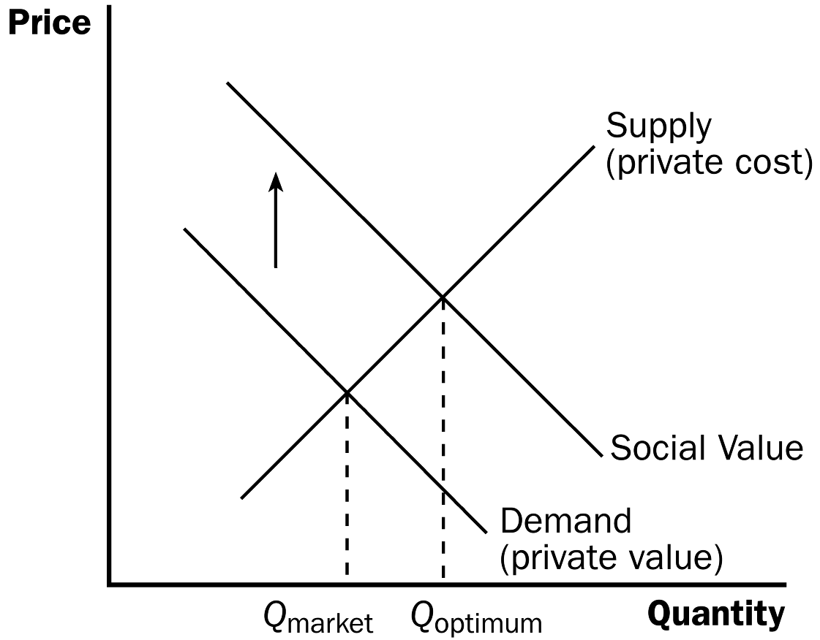

Make sure that students realize how heavily subsidized education is in the United States – both primary education and secondary education.

6. Case Study: Technology Spillovers, Industrial Policy, and Patent Protection

a. A technology spillover occurs when one firm’s research and production efforts impact another firm’s access to technological advance.

b. It is difficult to measure the amounts of technology spillover that occur and this leads to a debate over whether or not the government should pursue policies to encourage the production of technology.

c. Patent protection is a type of technology policy of the government because it protects the rights of inventors who create new technologies. Without patents, there would be less incentive to develop new ideas and technologies.

III. Public Policies toward Externalities

A. When an externality causes a market to reach an inefficient allocation of resources, the government can respond in two ways.

1. Command-and-control policies regulate behavior directly.

2. Market-based policies provide incentives so that private decisionmakers will choose to solve the problem on their own.

B. Command-and-Control Policies: Regulation

1. Externalities can be corrected by requiring or forbidding certain behaviors.

2. In the United States, the Environmental Protection Agency (EPA) develops and enforces regulations aimed at protecting the environment.

3. EPA regulations include maximum levels of pollution allowed or required adoption of a particular technology to reduce emissions.

C. Market-Based Policy 1: Corrective Taxes and Subsidies

1. Externalities can be internalized through the use of taxes and subsidies.

2. Definition of corrective tax: a tax designed to induce private decisionmakers to take account of the social costs that arise from a negative externality.

a. These taxes are preferred by economists over regulation, because firms that can reduce pollution with the least cost are likely to do so (to avoid the tax) while firms that encounter high costs when reducing pollution will simply pay the tax.

b. Thus, this tax allows firms that face the highest cost of reducing pollution to continue to pollute while encouraging less pollution over all.

c. Unlike other taxes, corrective taxes do not cause a reduction in total surplus. In fact, they increase economic well-being by forcing decisionmakers to take into account the cost of all of the resources being used when making decisions.

3. Case Study: Why Is Gasoline Taxed So Heavily?

a. In the United States, almost half of what drivers pay for gasoline goes to gas taxes.

b. This is to correct for three negative externalities associated with driving: congestion, accidents, and pollution.

D. Market-Based Policy 2: Tradable Pollution Permits

1. Example: EPA regulations restrict the amount of pollution that two firms can emit at 300 tons of glop per year. Firm A wants to increase its amount of pollution. Firm B agrees to decrease its pollution by the same amount if Firm A pays it $5 million.

2. Social welfare is increased if the EPA allows this situation. Total pollution remains the same so there are no external effects. If both firms are doing this willingly, it must make them better off.

3. If the EPA issued permits to pollute and then allowed firms to sell them, this would also increase social welfare. Firms that could control pollution most inexpensively would do so and sell their permits, while those who encounter high costs when reducing pollution would buy additional permits.
Figure 4

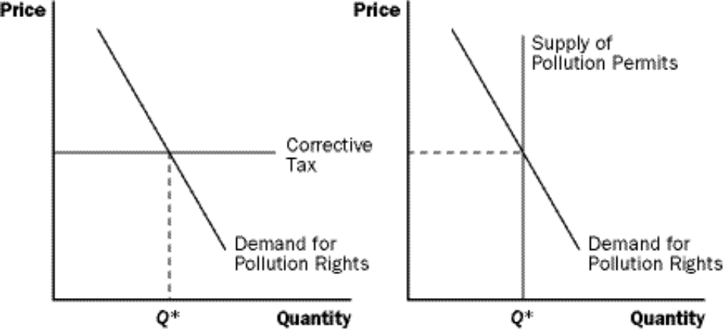

4. Tradable pollution permits and corrective taxes are similar in effect. In both cases, firms must pay for the right to pollute.

a. In the case of the tax, the government basically sets the price of pollution and firms then choose the level of pollution (given the tax) that maximizes their profit.

b. If tradable pollution permits are used, the government chooses the level of pollution (in total, for all firms) and firms then decide what they are willing to pay for these permits.

E. Objections to the Economic Analysis of Pollution

Stress to students that the socially optimal level of pollution is not “zero.” Make sure that they understand that society faces a trade-off because of the resources used to combat pollution.

1. Some individuals dislike the idea of allowing companies to purchase the right to pollute.

2. Economists point out that “people face trade-offs” (Principle #1) and we must decide how much we would be willing to give up in exchange for no pollution. It would likely not be enough.

3. A clean environment can be viewed as any other good that obeys the law of demand. The lower the price of environmental protection, the more the public will want.

F. In the News: What Should We Do about Climate Change?

1. Many policy analysts believe that taxing carbon is the best approach to dealing with global climate change..

2. This article from The New York Times explains how the revenue-neutral carbon tax works in British Columbia and argues for its implementation in the United States..

IV. Private Solutions to Externalities

A. We do not necessarily need government involvement to correct externalities.

B. The Types of Private Solutions

1. Problems of externalities can sometimes be solved by moral codes and social sanctions.

a. Do not litter.

b. The Golden Rule

2. Many charities have been established that deal with externalities. The government encourages this private solution by allowing a deduction for charitable contributions in the determination of taxable income.

a. Sierra Club (environment)

b. University Alumni Association (scholarships)

3. The parties involved in this externality (either the seller and the bystander or the consumer and the bystander) can possibly enter into an agreement to correct the externality.

C. The Coase Theorem

1. Definition of Coase theorem: the proposition that if private parties can bargain without cost over the allocation of resources, they can solve the problem of externalities on their own.

2. Example: Dick owns a dog Spot who disturbs a neighbor (Jane) with its barking.

a. One possible solution to this problem would be for Jane to pay Dick to get rid of the dog. The amount that she would be willing to pay would be equal to her valuation of the costs of the barking. Dick would only agree to this if Jane paid him an amount greater than the value he places on owning Spot.

b. Even if Jane could legally force Dick to get rid of Spot, another solution could occur. Dick could pay Jane to let him keep the dog.

3. Whatever the initial distribution of rights, the parties involved in an externality can potentially solve the problem themselves and reach an efficient outcome where both parties are better off.
D. Why Private Solutions Do Not Always Work

1. Definition of transaction costs: the costs that parties incur in the process of agreeing and following through on a bargain.

2. Coordination of all of the interested parties may be difficult so that bargaining breaks down. This is especially true when the number of interested parties is large.

SOLUTIONS TO TEXT PROBLEMS:

Quick Quizzes

1. Examples of negative externalities include pollution, barking dogs, and consumption of alcoholic beverages. Examples of positive externalities include the restoration of historic buildings, research into new technologies, and education. (Many other examples of negative and positive externalities are possible.) Market outcomes are inefficient in the presence of externalities because markets produce a larger quantity than is socially desirable when there is a negative externality and a smaller quantity than is socially desirable when there is a positive externality. The market outcomes do not account for all of the costs (negative externalities) or benefits (positive externalities) to society.

2. The town government might respond to the externality from the smoke in three ways: (1) regulation; (2) corrective taxes; or (3) tradable pollution permits.

Regulation prohibiting pollution beyond some level is good because it is often effective at reducing pollution. But doing so successfully requires the government to have a lot of information about the industries and the alternative technologies that those industries could adopt.

Corrective taxes are a useful way to reduce pollution because the tax can be increased to get pollution to a lower level and because the taxes raise revenue for the government. The tax is more efficient than regulation because it gives factories economic incentives to reduce pollution and to adopt new technologies that pollute less. The disadvantage of corrective taxes is that the government needs to know a lot of information to pick the right tax rate.

Tradable pollution permits are similar to corrective taxes but allow the firms to trade the right to pollute with each other. As a result, the government does not need as much information about the firms’ technologies. The government can simply set a limit on the total amount of pollution, issue permits for that amount, and allow the firms to trade the permits. This reduces pollution while allowing economic efficiency.

3. Examples of private solutions to externalities include moral codes and social sanctions, charities, and relying on the interested parties entering into contracts with one other.

The Coase theorem is the proposition that if private parties can bargain without cost over the allocation of resources, they can solve the problem of externalities on their own.

Private economic participants are sometimes unable to solve the problems caused by an externality because of transaction costs or because bargaining breaks down. This is most likely when the number of interested parties is large.

Questions for Review

1. Examples of negative externalities include pollution, barking dogs, and consumption of alcoholic beverages. Examples of positive externalities include the restoration of historic buildings, research into new technologies, and education. (Many other examples of negative and positive externalities are possible.)

2. Figure 1 illustrates the effect of a negative externality. The equilibrium quantity provided by the market is Q_{market}. Because of the externality, the social cost of production is greater than the private cost of production, so the social-cost curve is above the supply curve. The optimal quantity for society is Q_{optimum}. The private market produces too much of the good because Q_{market} is greater than Q_{optimum}.

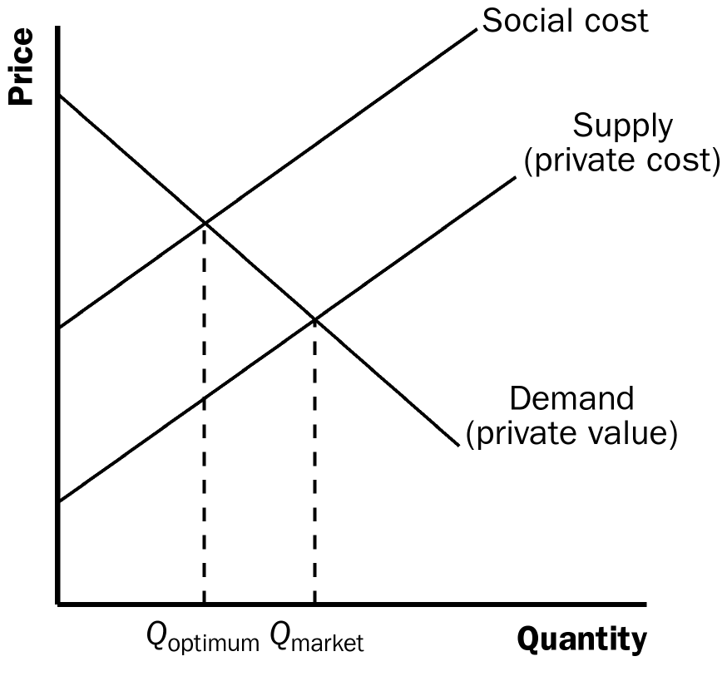

Figure 1

3. The patent system helps society solve the externality problem from technology spillovers. By giving inventors exclusive use of their inventions for a certain period, the inventor can capture much of the economic benefit of the invention. In doing so, the patent system encourages research and technological advance, which benefits society through spillover effects.

4. Corrective taxes are taxes enacted to correct the effects of a negative externality. Economists prefer corrective taxes over regulations as a way to protect the environment from pollution because they can reduce pollution at a lower cost to society. A tax can be set to reduce pollution to the same level as a regulation. The tax has the advantage of letting the market determine the least expensive way to reduce pollution. The tax gives firms incentives to develop cleaner technologies to reduce the taxes they have to pay.

5. Externalities can be solved without government intervention through moral codes and social sanctions, charities, merging firms whose externalities affect each other, or by contract.

6. According to the Coase theorem, you and your roommate will bargain over whether your roommate will smoke in the room. If you value clean air more than your roommate values smoking, the bargaining process will lead to your roommate not smoking. But if your roommate values smoking more than you value clean air, the bargaining process will lead to your roommate smoking. The outcome is efficient as long as transaction costs do not prevent an agreement from taking place. The solution may be reached by one of you paying off the other either not to smoke or for the right to smoke.

Quick Check Multiple Choice

1. c

2. b

3. a

4. c

5. b

6. c

Problems and Applications

1. The Club conveys a negative externality on other car owners because car thieves will not attempt to steal a car with The Club visibly in place. This means that they will move on to another car. The Lojack system conveys a positive externality because thieves do not know which cars have this technology. Therefore, they are less likely to steal any car. Policy implications include a subsidy for car owners that use the Lojack technology or a tax on those who use The Club.

2. a. Fire extinguishers exhibit positive externalities because even though people buy them for their own use, they may prevent fire from damaging the property of others.
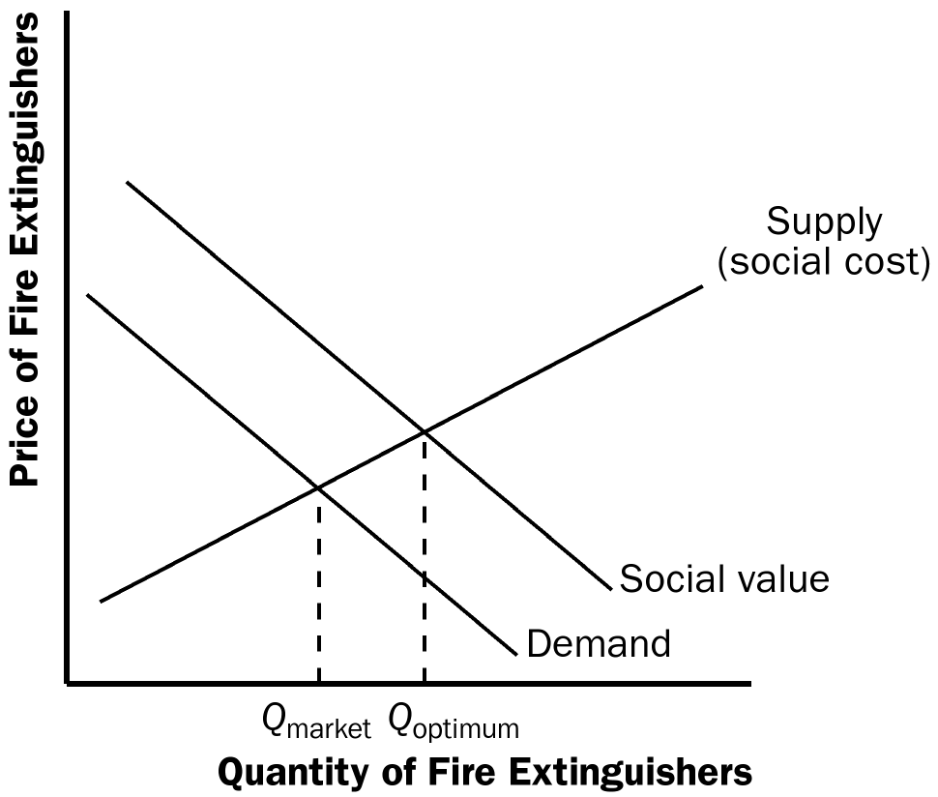

Figure 2

b. Figure 2 illustrates the positive externality from fire extinguishers. Notice that the social-value curve is above the demand curve and the social-cost curve is the same as the supply curve.

c. The market equilibrium level of output is denoted Q_{market} and the efficient level of output is denoted Q_{optimum}. The quantities differ because in deciding to buy fire extinguishers, people don't account for the benefits they provide to others.

d. A government policy that would result in the efficient outcome would be to subsidize people $10 for every fire extinguisher they buy. This would shift the demand curve up to the social-value curve, and the market quantity would increase to the optimum quantity.

3. a. The extra traffic is a negative externality because the social cost is greater than the private cost..

b. Figure 3 shows the market for theater tickets. Because there is no external benefit, the social-value curve is the same as the demand curve in this case. However, the social-cost curve lies $5 above the supply curve at each quantity. The efficient level of output occurs where the social-value curve (which is demand in this case) and the social-cost curve intersect..
social cost
Price of Tickets
Demand
(social value)
Supply
Q_{optimum}
Q_{market}
$5

Quantity of Tickets

Figure 3

c. This is a positive externality because the social value of theater tickets is greater than the private value in this case.

d. Figure 4 shows both the positive and the negative externalities.

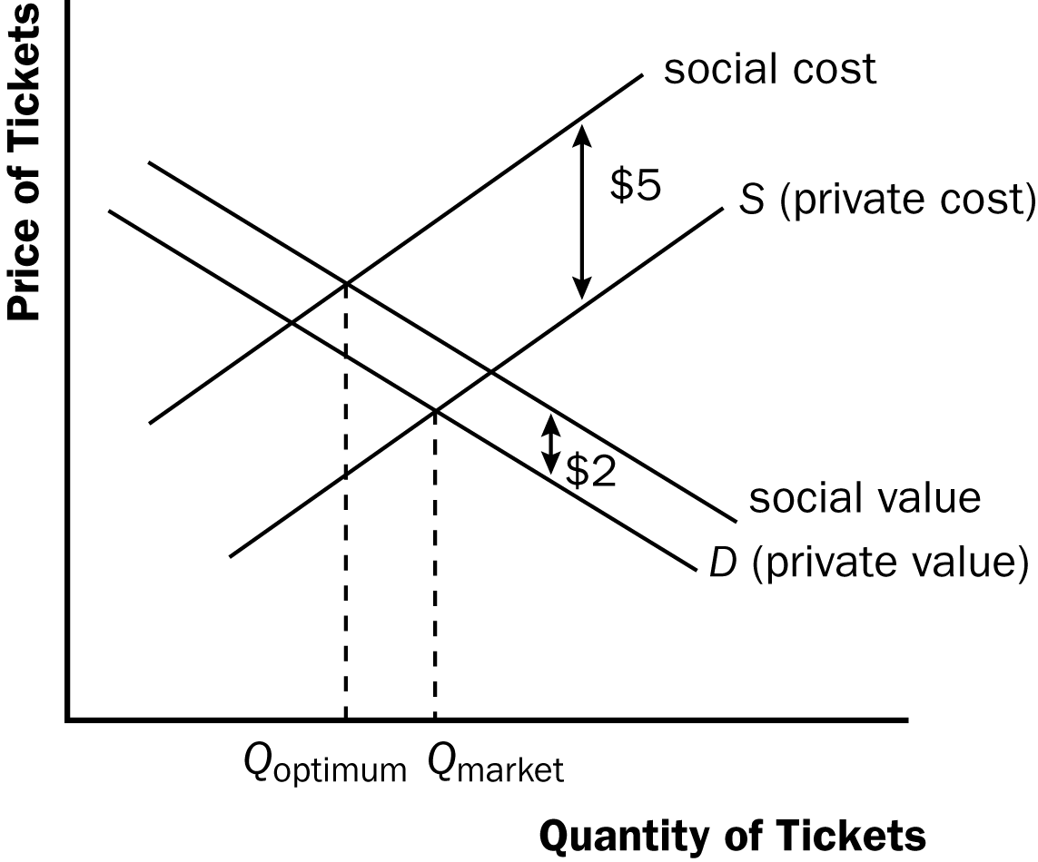

Figure 4

e. A tax of $3 per ticket will lead to the efficient outcome. The market equilibrium quantity will be equal to the social optimum.

4. a. The market for alcohol is shown in Figure 5. The social-value curve is the same as the demand curve in this case. The social-cost curve is above the supply curve because of the negative externality from increased motor vehicle accidents caused by those who drink and drive. The market equilibrium level of output is Q_{market} and the efficient level of output is Q_{optimum}.

b. The triangular area between points A, B, and C represents the deadweight loss of the market equilibrium. This area shows the amount by which social costs exceed social value for the quantity of alcohol consumption beyond the efficient level.

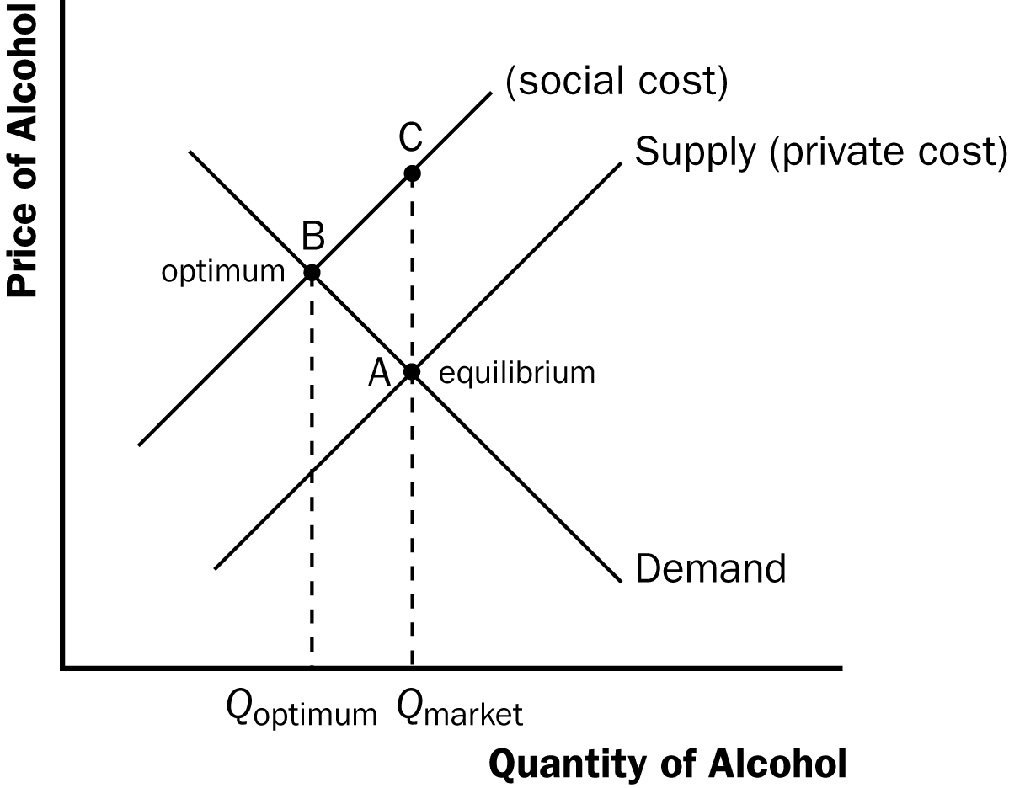

Figure 5

5. a. It is efficient to have different amounts of pollution reduction at different firms because the costs of reducing pollution differ across firms. If all firms were made to reduce pollution by the same amount, the costs would be low at some firms and prohibitively high at others, imposing a greater burden overall.

b. Command-and-control approaches that rely on uniform pollution reduction among firms give the firms no incentive to reduce pollution beyond the mandated amount. Instead, every firm will reduce pollution by just the amount required and no more.

c. Corrective taxes or tradable pollution rights give firms greater incentives to reduce pollution. Firms are rewarded by paying lower taxes or spending less on permits if they find methods to reduce pollution, so they have the incentive to engage in research on pollution control. The government does not have to figure out which firms can reduce pollution the most⎯it lets the market give firms the incentive to reduce pollution on their own.

6. a. At a price of $1.50, each Whovillian will consume 4 bottles of Zlurp. Each consumer’s total willingness to pay is $14 (= $5 + $4 + $3 + $2). The total spent by each Whovillian on Zlurp is $6 (= $1.50 × 4). Therefore, each consumer receives $8 in consumer surplus (=$14 − $6).

b. Total surplus would fall by $4 to $4.

c. If Cindy Lou only consumes 3 bottles of Zlurp, her consumer surplus is $4.50. Her willingness to pay for 3 bottles is $5 + $4 + $3 = $12. She pays $1.50 x 3 = $4.50 and the externality is $1 x 3 = $3. Thus, Cindy Lou's consumer surplus is $12 - $4.50 - $3.00 = $4.50. Cindy’s decision increases consumer surplus in Whoville by $0.50 ($4.50-$4.00).

d. The $1 tax raises the price of a bottle of Zlurp to $2.50. (The entire tax will be borne by consumers because supply is perfectly elastic.) Each resident will purchase only 3 bottles at the higher price and each consumer’s total willingness to pay is now $12 (= $5 + $4 + $3). Each resident pays $7.50 (= $2.50 × 3). Therefore, each resident receives $4.50 ($12-$7.50) in consumer surplus.

Because each bottle has an external cost of $1, the per-resident external cost is $3 ($1 per bottle x 3 bottles). The government collects $3 per resident in revenue. Total surplus with the tax is equal to $4.50 - $3.00 + $3.00 = $4.50.

e. Yes, because total surplus is now higher than before the tax.

7. a. The externality is noise pollution. Ringo’s consumption of rock and roll music affects Luciano, but Ringo does not consider that in deciding how loudly he plays his music.

b. The landlord could impose a rule that music could not be played above a certain decibel level. This could be inefficient because there would be no harm done by Ringo playing his music loud if Luciano is not home.

c. Ringo and Luciano could negotiate an agreement that might, for example, allow Ringo to play his music loudly at certain times of the day. They might not be able to reach an agreement if the transaction costs are high or if bargaining fails because each holds out for a better deal.

8. a. An improvement in the technology for controlling pollution would reduce the demand for pollution rights, shifting the demand curve to the left. Figure 6 illustrates what would happen if there were a corrective tax, while Figure 7 shows the impact if there were a fixed supply of pollution permits. In both figures, the curve labeled D₁ is the original demand for pollution rights and the curve labeled D₂ is the new demand for pollution rights after the improvement in technology.

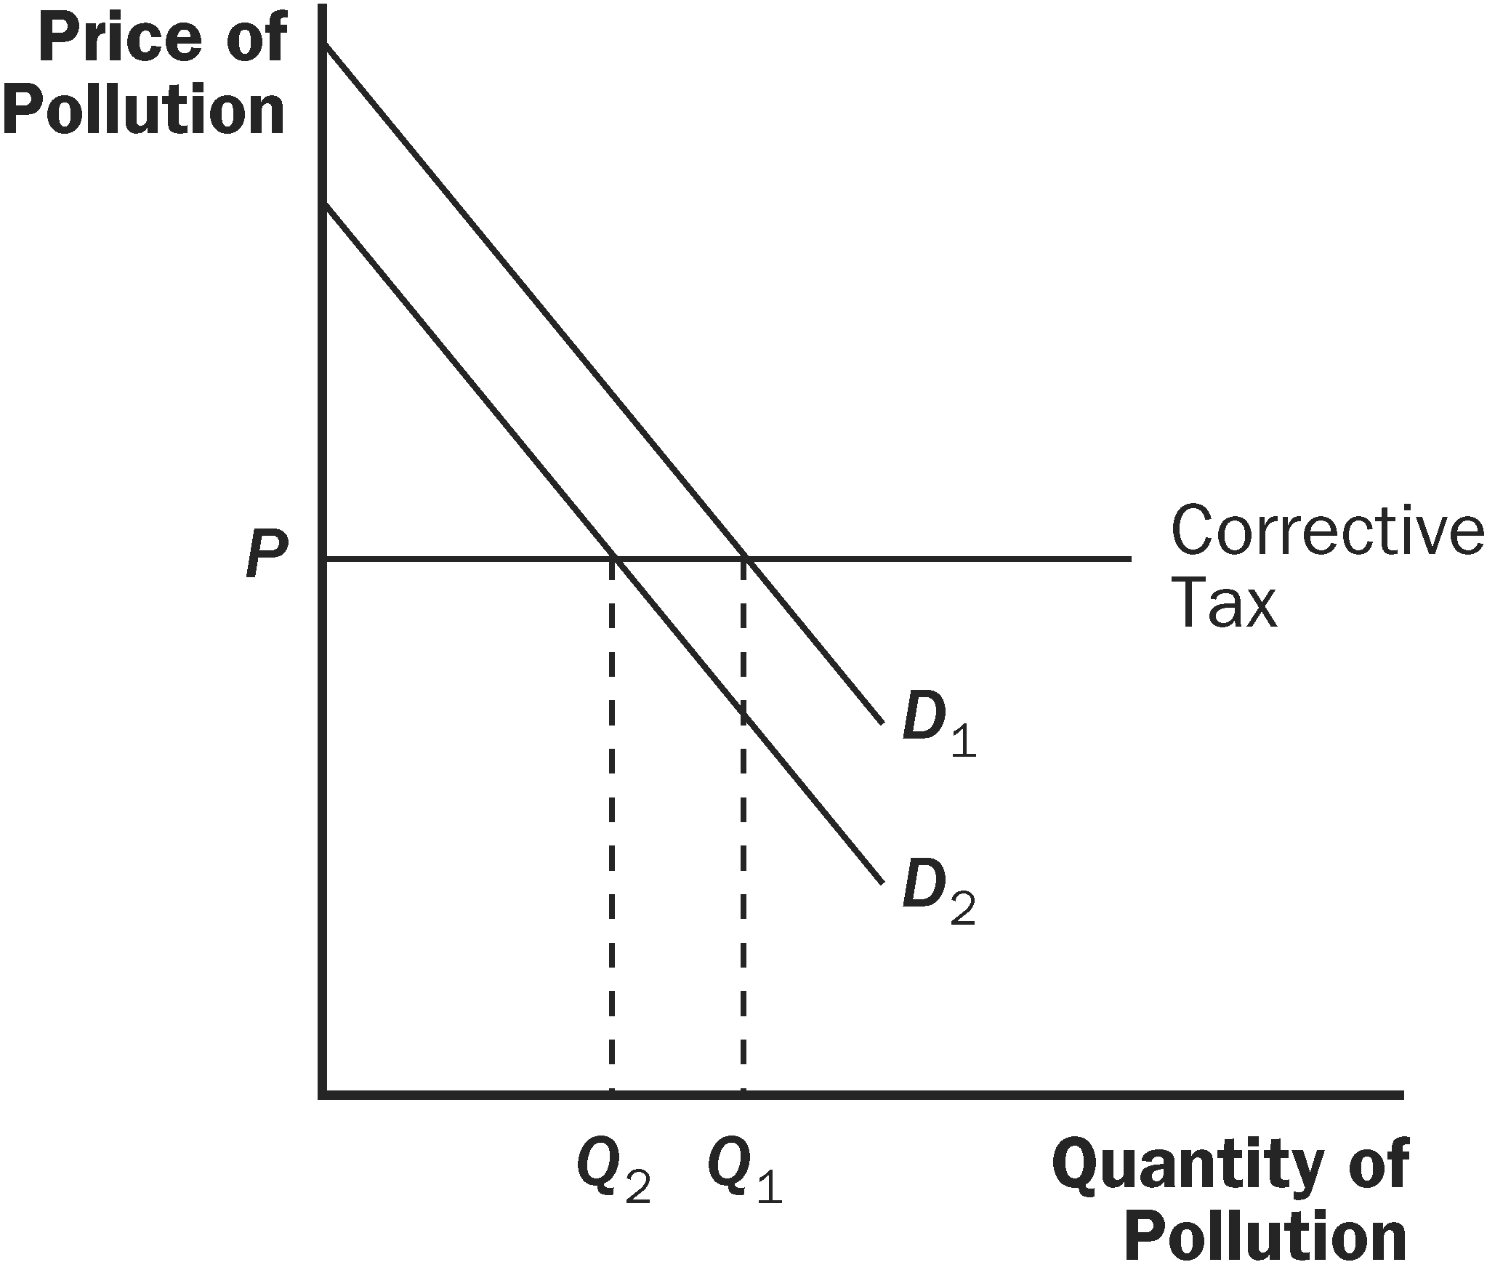

Figure 6

b. With a corrective tax, the price of pollution remains unchanged and the quantity of pollution declines, as Figure 6 shows. With pollution permits, the price of pollution declines and the quantity of pollution is unchanged, as Figure 7 illustrates.

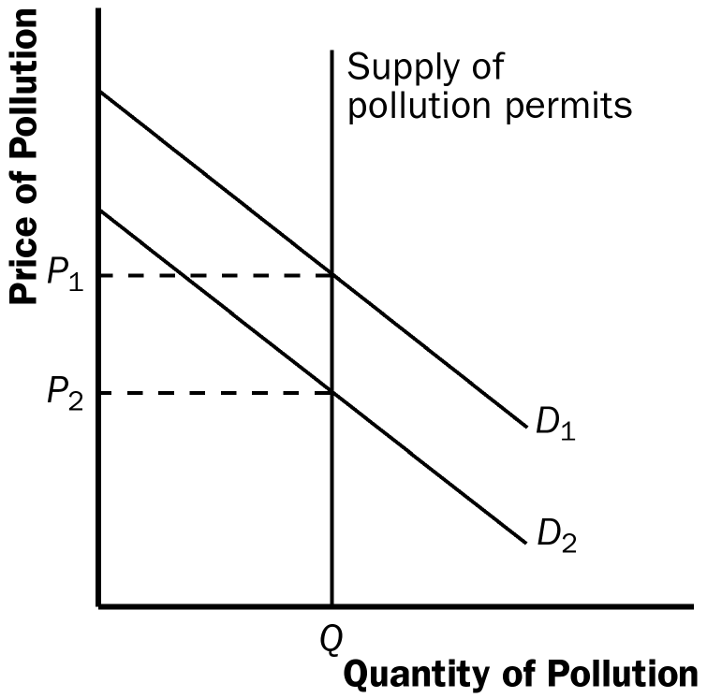

Figure 7

9. a. In terms of economic efficiency in the market for pollution, it does not matter if the government distributes the permits or auctions them off, as long as firms can sell the permits to each other. The only difference would be that the government could make money if it auctioned the permits off, thus allowing it to reduce taxes, which would help reduce the deadweight loss from taxation. There could also be some deadweight loss occurring if firms use resources to lobby for additional permits.

b. If the government allocated the permits to firms who did not value them as highly as other firms, the firms could sell the permits to each other so they would end up in the hands of the firms who value them most highly. Thus, the allocation of permits among firms would not matter for efficiency. But it would affect the distribution of wealth, because those who got the permits and sold them would be better off.

10. a. The firms with the highest cost of reducing pollution will buy permits rather than reduce their pollution. Firms that can sell their permits for more than it costs them to reduce their pollution will sell.

Because firm B faces the highest costs of reducing pollution, $25 per unit, it will keep its own 40 permits and buy 40 permits from the other firms, so that it can still pollute 80 units. Thus, firm B does not reduce its pollution at all.

Of the two remaining firms, firm A has the higher cost of reducing pollution so it will keep its own 40 permits and reduce its pollution by 30 units at a cost of $20 x 30 units = $600.

Firm C sells all 40 of its permits to firm B and reduces its pollution by 50 units at a cost of $10 × 50 = $500. The total cost of pollution reduction is $1,100.

b. If the permits could not be traded, then firm A would have to reduce its pollution by 30 units at a cost of $20 × 30 = $600, firm B would have to reduce its pollution by 40 units at a cost of $25 × 40 = $1,000, and firm C would have to reduce its pollution by 10 units at a cost of $10 × 10 = $100. The total cost of pollution reduction would be $1,700, $600 higher than in the case in which the permits could be traded.

